

**CSE 360**

**Lab Project Proposal Submission**

**FALL 2023**

**Group No:** 05

**Project Name:** Smart Cane for the Visually Impaired

**Group members**:

Dipak Debnath Arka (20301066)

Rawnak Muntaha Anan (20101513)

Nusaibah Rahat (20301136)

Rakibul Hassan Hredoy (20101357)

Mirza Fahad Bin Kamal (20101399)

**Submitted to**:

Shakir Rouf (SKR)

C. Lecturer

Department of Computer Science and Engineering

Mehedi Hasan Emo

C. Lecturer

Department of Computer Science and Engineering

**Submitted on**:

27-11-2023

# **Introduction**

Considering that roughly 83% of the data is assimilated by our eyes from our surroundings, they play an important part in human existence. Sadly, a great number of people lack this ability and they need external assistance in their mobility. The primary goal of this project is to make it possible for blind people to navigate with self-assurance and to remain vigilant should their walking path become impeded by any obstacles. The essential qualities for the stick to benefit each and every person who is visually impaired and be cost-effective. People, cars and puddles are some examples of obstacles for blind people. The sensors used are an ultrasonic sensor and a humidity sensor to detect any solid object or any damp surface ahead of the user. A DC motor and a buzzer is used as outputs In the circuit. The buzzer acts as a warning indicator, beeping if both sensors detect obstacles. The stick may additionally identify damp and wet surfaces or a solid object and activate the DC motor to notify the user of any obstacle. We have shown through this project how well Arduino and sensors work together to provide a straightforward and effective smart cane for the blind. We intend to enhance the lives of the visually impaired and make a positive impact on the medical equipment industry by putting our method into practical use.

# **Application Area**

**Medical Instrument**

This project focuses on developing a cost-effective and efficient system for obstacle detection and navigation assistance for visually impaired individuals. The YL-69 Humidity and Moisture Detection Sensor, HC-SR04 Ultrasonic Sensor, Arduino Uno R3, Buzzer, and Motor are all used. The ultrasonic sensor measures the time it takes for sound waves to bounce back after it emits them in order to identify impediments. An audio alert is provided by a buzzer, and damp surfaces are detected by a moisture detection sensor. By offering real-time obstacle identification and navigation support, this technology seeks to improve mobility and safety for people with visual impairments.

# **Technology and tools**

1. Arduino Uno R3
2. HC-SR04 Ultrasonic Sensor
3. YL-69 Humidity and Moisture Detection Sensor
4. Buzzer
5. L298N Motor Driver
6. 4V DC Motor

# **Programming language**

Arduino IDE has been used for this project, which requires a variant of C++ for writing codes. Furthermore, this IDE also has excellent compatibility with the model of Arduino microcontroller we have used in this project and is easy to use.

# **Working mechanism of Sensors**

**HC-SR04 ultrasonic sensor**

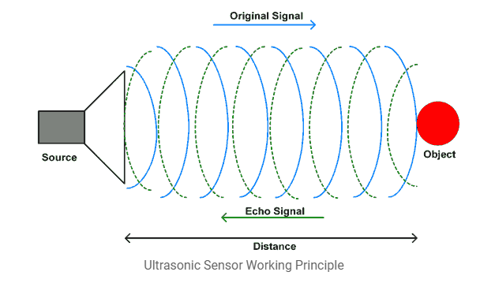

Here step-by-step working mechanism of HC-SR04 ultrasonic sensor: At first, The HC-SR04 sensor receives a trigger signal to initiate a measurement. A strong signal (5V) of at least 10 microseconds is usually what it consists of. Any controlling device, such as a microcontroller, can produce the trigger signal. The trigger signal causes the HC-SR04 sensor to release a brief burst of ultrasonic sound waves. These sound waves normally have a frequency of about 40 kHz, which is above the range of human hearing. The sound waves that are released from the sensor travel through the atmosphere in every direction. They spread out until they come into contact with a surface or an object.[1] Then , Sound waves are reflected off surfaces or bounce back when they collide with them. These reflected waves, or echoes, are picked up by the HC-SR04 sensor. It is measured how long it takes for sound waves to travel from the sensor to the object and return. The trigger signal's time and the received echo's time are compared to achieve this. This time is usually represented by a digital output from the HC-SR04 sensor. The distance to the object can be computed using the measured time. You can calculate the distance in centimeters or inches by dividing the duration by two and multiplying the result by the sound speed, which is approximately 343 meters per second in air.[2]

**YL-69 Humidity and Moisture Detection Sensor:**

Here step-by-step working mechanism of YL-69 Humidity and Moisture Detection Sensor: At first, Two probes are put into the soil to make up the YL-69 sensor. The electrical resistance is measured by one probe, and the moisture content is measured by the other. Low electrical conductivity soil occurs when it is dry, while soil electrical conductivity rises with increasing moisture content. This is because water functions as an electrolyte, which facilitates the easier flow of electrical current. [3] Then, The YL-69 sensor measures the resistance between the probes to ascertain the soil's moisture content. Usually, it outputs an analog value that corresponds to the resistance. It is advised to calibrate the sensor by measuring the resistance in both wet and dry soil before using it. The establishment of a reference point for precise moisture readings is aided by this calibration. [4] Moreover, The YL-69 sensor can detect moisture and measure the relative humidity of surrounding environments. It measures the relative humidity in the air using a sensor device. The sensor outputs an electrical signal that corresponds to the relative humidity reading. The YL-69 sensor's analog readings can be processed using a microcontroller or other data acquisition devices. The gathered data may be used for additional analysis, control, or display, depending on the particular application.[5]

# **Connection with ICs**

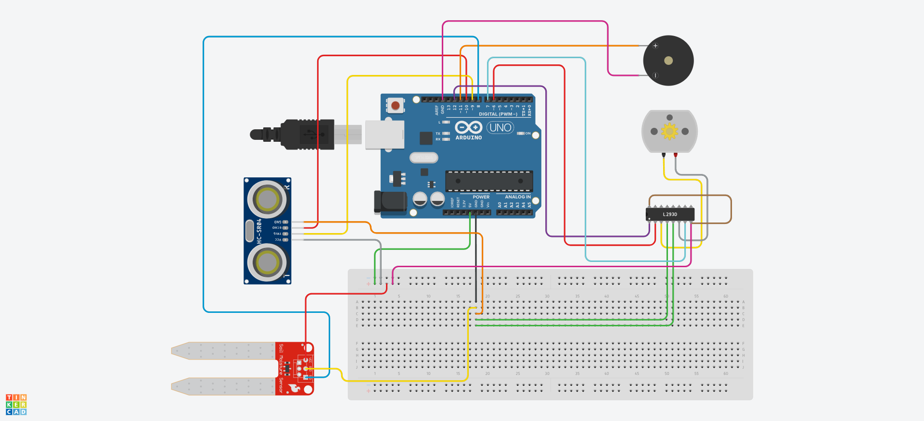

# **Data flow from sensors through ICs to I/O devices**

Our system has three functionalities, one is proximity sensing, second is liquid detection and the third is to convey this information to the user.

Using the ultrasonic sensor we will be able to detect if any object is close to the cane. The ultrasonic sensor will send the time it takes to receive back its signal to the arduino which will then calculate if the object has come closer than the threshold. If the distance is less than the threshold then the arduino will send a signal to the vibration motor driver to vibrate once. Similarly if the moisture sensor detects water it will send that data to the arduino which will now send a signal to the motor driver to vibrate the motor twice. In case of these two scenarios both happening simultaneously, the arduino will send the signal to the buzzer to beep and warn the user.

# **Estimated cost analysis**

| **Components** | **Quantity** | **Price (BDT)** |
| --- | --- | --- |
| Arduino Uno R3 | 1 | 1100 |
| HC-SR04 Ultrasonic Sensor | 1 | 93 |
| YL-69 Humidity Sensor | 1 | 120 |
| L298N H-Bridge Dual Motor Driver | 1 | 195 |
| DC Motor (4V 2000 RPM) | 1 | 40 |
| 5V Passive Buzzer | 1 | 15 |
| 9V Battery | 1 | 80 |
| 2.1mm Battery Connector | 1 | 22 |
| Breadboard | 1 | 150 |
| Jumper Wire | 30 | 90 |
| **Total** | 38 | **1905** |

# **Responsibilities of each member**

Dipak Debnath Arka: Technology and tools, Working mechanism of Sensors

Rawnak Muntaha Anan: Cover Page, Application Area

Nusaibah Rahat: Introduction, Conclusion

Rakibul Hassan Hredoy: Data flow from sensors through ICs to I/O devices, Gantt Chart

Mirza Fahad Bin Kamal: Programming language, Connection with ICs, Estimated cost analysis

# **Gantt Chart**

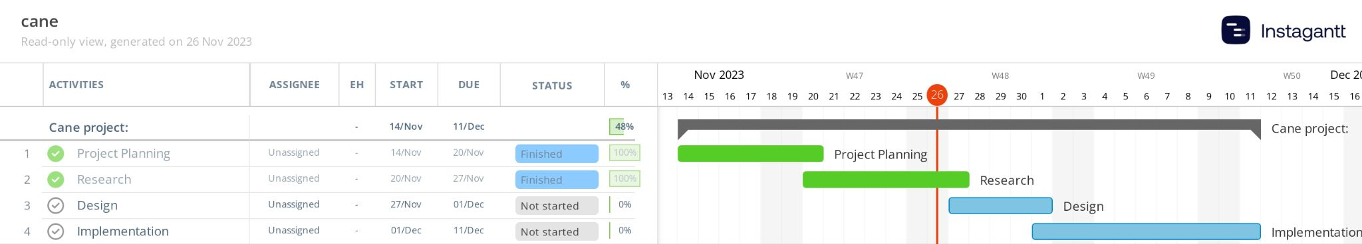

# **Conclusion**

By the end of the project, we can say that it will reduce the risks of injuries that people with visual impairments face when they walk in public. The primary benefit of this project is that it has the potential to be extremely inexpensive and a global solution for millions of blind people. This project tries to guarantee a sense of safety and security for the visually impaired. Despite the stick's hard wire construction and sensors, it remains devoid of weight. Being quite inexpensive, the project has some drawbacks like not being able to detect obstacles behind the user or at head level and other obstacles like downward stairs. Still, this project has demonstrated the potential to be very useful and easy to use for those who are blind.

# **References**

1. <https://www.electronicwings.com/sensors-modules/ultrasonic-module-hc-sr04>
2. <https://lastminuteengineers.com/arduino-sr04-ultrasonic-sensor-tutorial/>
3. <https://randomnerdtutorials.com/guide-for-soil-moisture-sensor-yl-69-or-hl-69-with-the-arduino/>
4. <https://www.vernier.com/manuals/sms-bta/>
5. <https://www.ncbi.nlm.nih.gov/pmc/articles/PMC4063076/>